

SCHOOL OF COMPUTING

Department of Computer Science and Engineering

CERTIFICATE

This is to certify that the Cornerstone project work entitled “INVENTORY MANAGEMENT SYSTEM” is submitted by
M BHARATHI | (25B11CS530)
G HARISHA | (25B11CS280)
Y MAHESWARI | (25B11CSA33)
E MANIKANTA | (25B11CS255)

in partial fulfillment of the requirements for the award of the B.Tech. degree in Computer Science and Engineering for the academic year 2026-2027.

Project Guide Head of the Department
Mrs. K Vydehi, M.Tech.,(Ph.D), Dr. Phani Sridhar Addepalli, Ph.D,
Assistant Professor, Assistant Professor,
Department of CSE Department of CSE

DECLARATION

We hereby declare that the Cornerstone project entitled “INVENTORY MANAGEMENT SYSTEM” is original and is submitted to ADITYA UNIVERSITY, Surampalem, in partial fulfillment of the requirements for the award of the B.Tech. Degree in Computer Science and Engineering. We further declare that this project work has not been submitted, either in full or in part, for the award of any degree in this or any other institution. We also confirm that this work complies with the Institutional Academic Integrity and AI Usage Policy

Place: Surampalem
Date:
By
M BHARATHI | (25B11CS530)
G HARISHA | (25B11CS280)
Y MAHESWARI | (25B11CSA33)
E MANIKANTA | (25B11CS255)

ACKNOWLEDGEMENT

It is with immense pleasure that we express our sincere gratitude to our Cornerstone Project Guide, Mrs. K Vydehi, Assistant Professor, who has guided us throughout the project. Her valuable support, encouragement, and guidance have greatly contributed to the successful completion of this work.
We would like to thank our Deputy Heads of the Department, Dr. Chandra Sekhar Kolli, Associate Professor, Dr Hari Jyothula, Associate Professor and Dr Pennada Siva Satya Prasad, Assistant Profeesor, Department of Computer Science and Engineering, for their support and valuable suggestions.
Our deepest thanks to our Head of the Department Dr. Phani Sridhar Addepalli, Assistant Professor, for his inspiration and for providing all the necessary facilities and resources required for this project.
We also extend our sincere thanks to Dr. M.V. Rajesh, Associate Dean, School of Computing for their encouragement and support during the course of our project.
We would like to express our sincere gratitude to Dr. G. Suresh, Registrar, Dr. A Ramesh, Pro Vice-Chancellor (Engineering & Sciences), Dr. S. Rama Sree, Pro Vice-Chancellor (Academics), Dr. M.B. Srinivas, Vice-Chancellor, Dr. M. Sreenivasa Reddy, Deputy Pro Chancellor and Management, Aditya University for providing excellent infrastructure and state-of-the-art laboratories.
Finally, we would like to thank the faculty members, lab technicians, non-teaching staff, and our friends who have directly or indirectly supported us in completing this Cornerstone project successfully.

TABLE OF CONTENTS
S.No. | Title | Page No
1 | Cover page
2 | Certificate
3 | Acknowledgement
4 | Table of Contents
5 | Abstract
6 | Introduction |  | 2
7 | System analysis |  | 3-5
8 | Database design |  | 6-7
9 | ER diagram |  | 8
10 | Relational schema |  | 9
11 | Table design |  | 10-14
12 | Normalisation |  | 15
13 | SQL implementation |  | 16-20
14 | SQL queries & Screenshot |  | 21-26
15 | Conclusion and future enhancements |  | 27
16 | References |  | 28

ABSTRACT
The Inventory Management System is designed to automate and simplify the management of inventory activities through a centralized relational database. The system manages essential information related to products, categories, suppliers, purchases, sales, customers, and employees. It helps track product quantities, stock availability, purchases, and sales efficiently while identifying low-stock products using predefined reorder levels to prevent stock shortages and maintain appropriate inventory levels.
The system allows users to add, update, search, and retrieve inventory information efficiently, reducing manual effort and data-entry errors. Primary and foreign key relationships are used to maintain data integrity and consistency, while normalization up to Third Normal Form (3NF) reduces data redundancy. Overall, the project provides an organized and reliable foundation for inventory management and can be further extended into a complete web, desktop, or mobile-based application.

LIST OF FIGURES
Figure No. | Title | Page No
1 | ER Diagram of Inventory Management System | 14

LIST OF TABLES
Table No | Table Name | Page No
1 | Functional Requirements | 4
2 | Requirement Specification | 5
3 | Database Design | 6
4 | Relationships | 7
5 | Relational Schema | 9
6 | Product Table Structure | 10
7 | Category Table Structure | 10
8 | Supplier Table Structure | 11
9 | Purchase Table Structure | 11
10 | Purchase Details Table Structure | 11
11 | Customer Table Structure | 12
12 | Sales Table Structure | 12
13 | Sales Detail Table Structure | 12
14 | Employee Table Structure | 13
15 | Keys and Constraints | 13
16 | Sample Data Records | 14

ACRONYMS
DBMS – Database Management System
ER – Entity Relationship
SQL – Structured Query Language
DDL – Data Definition Language
DML – Data Manipulation Language
DQL – Data Query Language
DCL – Data Control Language
TCL – Transaction Control Language
PK – Primary Key
FK – Foreign Key
1NF – First Normal Form
2NF – Second Normal Form
3NF – Third Normal Form

1. INTRODUCTION

1.1 Brief Information about the Project
An Inventory Management System is a database application that manages inventory information and operational processes. The project provides a centralized relational database for products, categories, suppliers, purchases, sales, customers, employees, and stock-related transactions. It is intended to replace fragmented manual records and disconnected files with a structured database that supports consistent storage, efficient retrieval, and reporting.

1.2 Motivation and Contribution of Project
The project is motivated by common problems in inventory record management such as duplicate product information, difficulty in tracking stock, manual purchase and sales updates, delayed low-stock identification, time-consuming searches, and difficulty in generating consolidated inventory reports.
- Centralizing inventory records in one relational database.
- Reducing duplicate and inconsistent information.
- Maintaining referential integrity using primary and foreign keys.
- Supporting faster product, purchase, sales, and stock queries.
- Identifying products that reach their reorder level.
- Providing a foundation for inventory reporting and future application development.

1.3 Objectives of the Project
- Develop a centralized inventory database.
- Maintain accurate product and category records.
- Store supplier and purchase information.
- Record sales and customer information.
- Automatically support stock quantity tracking.
- Identify low-stock products using reorder levels.
- Reduce manual work and data-entry errors.
- Support efficient SQL queries and inventory reports.

1.4 Scope of the Project
The scope covers database-oriented management of core inventory operations. The core scope includes product, category, supplier, purchase, purchase-detail, customer, sales, sales-detail, and employee data. The database can later be extended with barcode scanning, warehouse management, online ordering, advanced dashboards, supplier payments, purchase returns, sales returns, and role-based application access.

2. SYSTEM ANALYSIS

2.1 Existing System
- Manual record maintenance.
- Multiple Excel sheets or disconnected files.
- Duplicate product and supplier information.
- Difficulty in tracking current stock quantities.
- Delayed updates after purchases and sales.
- Difficulty in identifying low-stock products.
- Time-consuming inventory searches and report preparation.
- Higher possibility of data-entry and calculation errors.

2.2 Proposed System
The proposed system uses a centralized relational database. It organizes inventory information into related tables and uses primary keys, foreign keys, uniqueness rules, NOT NULL conditions, and suitable defaults to maintain consistency. The system supports product, category, supplier, purchase, sales, customer, employee, and inventory reporting management.
- Centralized inventory database
- Product and category management
- Supplier management
- Purchase and purchase-detail management
- Sales and sales-detail management
- Customer and employee management
- Stock and low-stock monitoring
- SQL-based reporting
- Referential integrity

2.3 Functional Requirements
Module | Functional Requirement
Product Management | Add, update, search, and display product details.
Category Management | Maintain categories and descriptions.
Supplier Management | Store supplier contact and address information.
Purchase Management | Record purchases and purchase details.
Sales Management | Record sales and sales details.
Stock Management | Maintain stock quantity and identify low-stock items.
Customer Management | Store customer details for sales transactions.
Employee Management | Maintain employee information and roles.
Search and Reporting | Retrieve inventory, purchase, sales, and stock information using SQL queries.

2.4 Non-Functional Requirements
- Performance – queries should return results efficiently for normal inventory workloads.
- Integrity – invalid references and duplicate key values should be prevented.
- Security – database privileges should be controlled for authorized users.
- Usability – forms and reports should be understandable to inventory staff.
- Reliability – transactions should preserve a consistent database state.
- Scalability – the design should support growth in products, suppliers, purchases, sales, and transactions.

2.5 Requirements Specification
Category | Suggested Requirement
Hardware | Intel i3 or above; 4 GB RAM minimum; adequate storage; standard display and keyboard/mouse.
Operating System | Windows 10/11 or an equivalent supported platform.
Database | MySQL, Oracle, PostgreSQL, or another compatible relational DBMS.
Application | A web, desktop, or mobile interface may be developed as the application layer.

3. DATABASE DESIGN


3.1 Major Entities
Entity | Description
Product | Stores product name, category, supplier, price, quantity, and reorder level.
Category | Stores product category names and descriptions.
Supplier | Stores supplier contact and address information.
Purchase | Stores purchase transaction header information.
Purchase_Details | Stores individual products included in purchases.
Customer | Stores customer records and contact information.
Sales | Stores sales transaction header information.
Sales_Details | Stores individual products included in sales.
Employee | Stores employee details and roles.

3.2 ER Model
The ER model represents the major entities and their relationships in the Inventory Management System. It connects products with categories and suppliers, purchases with suppliers and purchase details, sales with customers and employees, and sales details with products. Primary keys uniquely identify records while foreign keys connect related entities.

3.3 Relationships
Relationship | Description
Category → Product | One category can contain many products (1:M).
Supplier → Product | One supplier can supply many products (1:M).
Supplier → Purchase | One supplier can have many purchase transactions (1:M).
Purchase → Purchase_Details | One purchase can contain many purchase-detail records (1:M).
Product → Purchase_Details | One product can occur in many purchase-detail records (1:M).
Customer → Sales | One customer can have many sales transactions (1:M).
Employee → Sales | One employee can handle many sales transactions (1:M).
Sales → Sales_Details | One sale can contain many sales-detail records (1:M).
Product → Sales_Details | One product can occur in many sales-detail records (1:M).

4. ER DIAGRAM
Figure 1 presents the Entity Relationship Diagram of the Inventory Management System. The diagram shows the entities, attributes, primary identifiers, foreign keys, relationships, and cardinalities used to model inventory operations.

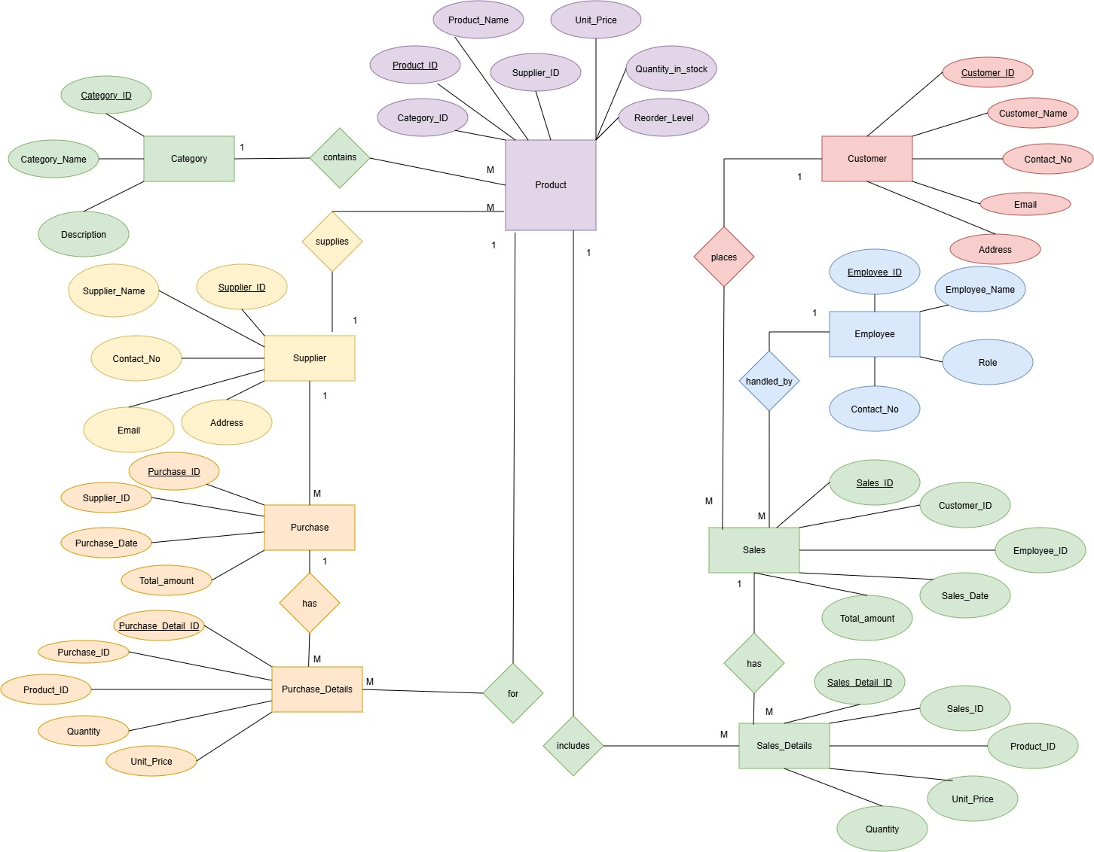

Figure 2: ER Diagram of Inventory Management System

5. RELATIONAL SCHEMA

Relation | Attributes (PK = Primary Key, FK = Foreign Key)
CATEGORY
  Category_ID (PK), Category_Name, Description
  SUPPLIER
  Supplier_ID (PK), Supplier_Name, Contact_No, Email, Address
  PRODUCT
  Product_ID (PK), Product_Name, Category_ID (FK), Supplier_ID (FK), Unit_Price, Quantity_in_stock, Reorder_Level
  PURCHASE
  Purchase_ID (PK), Supplier_ID (FK), Purchase_Date, Total_amount
  PURCHASE_DETAILS
  Purchase_Detail_ID (PK), Purchase_ID (FK), Product_ID (FK), Quantity, Unit_Price
  CUSTOMER
  Customer_ID (PK), Customer_Name, Contact_No, Email, Address
  EMPLOYEE
  Employee_ID (PK), Employee_Name, Role, Contact_No
  SALES
  Sales_ID (PK), Customer_ID (FK), Employee_ID (FK), Sales_Date, Total_amount
 | Sales_Detail_ID (PK), Sales_ID (FK), Product_ID (FK), Quantity, Unit_Price
  SALES_DETAILS

6.TABLE DESIGN

6.1 Product Table
Attribute | Data Type | Constraint | Description
Product_ID | INT | PK | Unique product identifier
Product_Name | VARCHAR(100) | NOT NULL | Product name
Category_ID | INT | FK | References Category
Supplier_ID | INT | FK | References Supplier
Unit_Price | DECIMAL(10,2) | NOT NULL | Price per unit
Quantity | INT | NOT NULL | Current stock quantity
Reorder_Level | INT | NOT NULL | Minimum stock threshold

6.2 Category Table
Attribute | Data Type | Constraint | Description
Category_ID | INT | PK | Unique category identifier
Category_Name | VARCHAR(50) | NOT NULL | Category name
Description | VARCHAR(150) |  | Category description

6.3 Supplier Table
Attribute | Data Type | Constraint | Description
Supplier_ID | INT | PK | Unique supplier identifier
Supplier_Name | VARCHAR(100) | NOT NULL | Supplier name
Contact_No | VARCHAR(15) | NOT NULL | Supplier contact number
Email | VARCHAR(80) | — | Supplier email
Address | VARCHAR(150) | — | Supplier address

6.4 Purchase Table
Attribute | Data Type | Constraint | Description
Purchase_ID | INT | PK | Unique purchase identifier
Supplier_ID | INT | FK | References Supplier
Purchase_Date | DATE | NOT NULL | Date of purchase
Total_Amount | DECIMAL(10,2) | NOT NULL | Total purchase value

6.5 Purchase_Details Table

Attribute | Data Type | Constraint | Description
Purchase_Detail_ID | INT | PK | Unique purchase-detail identifier
Purchase_ID | INT | FK | References Purchase
Product_ID | INT | FK | References Product
Quantity | INT | NOT NULL | Quantity purchased
Unit_Price | DECIMAL(10,2) | NOT NULL | Purchase price per unit

6.6 Customer Table

Attribute | Data Type | Constraint | Description
Customer_ID | INT | PK | Unique customer identifier
Customer_Name | VARCHAR(100) | NOT NULL | Customer name
Contact_No | VARCHAR(15) | — | Customer contact number
Email | VARCHAR(80) | — | Customer email

6.7 Sales Table
Attribute | Data Type | Constraint | Description
Sales_ID | INT | PK | Unique sales identifier
Customer_ID | INT | FK | References Customer
Employee_ID | INT | FK | References Employee
Sales_Date | DATE | NOT NULL | Date of sale
Total_Amount | DECIMAL(10,2) | NOT NULL | Total sales value

6.8 Sales_Details Table

Attribute | Data Type | Constraint | Description
Sales_Detail_ID | INT | PK | Unique sales-detail identifier
Sales_ID | INT | FK | References Sales
Product_ID | INT | FK | References Product
Quantity | INT | NOT NULL | Quantity sold
Unit_Price | DECIMAL(10,2) | NOT NULL | Selling price per unit

6.9 Employee Table

Attribute | Data Type | Constraint | Description
Employee_ID | INT | PK | Unique employee identifier
Employee_Name | VARCHAR(100) | NOT NULL | Employee name
Role | VARCHAR(50) | NOT NULL | Employee role
Contact_No | VARCHAR(15) | — | Employee contact number

6.10 KEYS AND CONSTRAINTS
Constraint Type | Applied To / Purpose
Primary Key | Product_ID,Category_ID,Supplier_ID,Purchase_ID, Purchase_Detail_ID,Customer_ID,Sales_ID,Sales_Detail_ID, Employee_ID
Foreign Key | Product.Category_ID→Category.Category_ID; Product.Supplier_ID→Supplier.Supplier_ID; Purchase.Supplier_ID → Supplier.Supplier_ID
Foreign Key | Purchase_Details.Purchase_ID→Purchase.Purchase_ID; Purchase_Details.Product_ID → Product.Product_ID
Foreign Key | Sales.Customer_ID→Customer.Customer_ID;  Sales.Employee_ID→Employee.Employee_ID; Sales_Details.Sales_ID → Sales.Sales_ID;  Sales_Details.Product_ID → Product.Product_ID
NOT NULL | Required identifiers,names, dates, quantities, and transaction values
UNIQUE | Can be applied to supplier/customer contact or email fields where required
CHECK | Quantity and reorder levels should not be negative

6.11 Sample Data Records
Table | Identifier | Main Data Value / Date
PRODUCT | 101 | Laptop / category 1 / supplier 10 / quantity 25
CATEGORY | 1 | Electronics
SUPPLIER | 10 | ABC Suppliers
PURCHASE | 501 | Supplier 10 / 2026-09-20 / 25000
PURCHASE_DETAILS | 1001 | Purchase 501 / Product 101 / Qty 10
CUSTOMER | 1 | Ravi / 9876543210
SALES | 701 | Customer 1 / Employee 201 / 2026-09-22
SALES_DETAILS | 9001 | Sale 701 / Product 101 / Qty 2
EMPLOYEE | 201 | Suresh / Sales Staff

7. NORMALIZATION
Normalization organizes data into related relations to reduce redundancy and update anomalies. The Inventory Management System separates product, category, supplier, purchase, purchase-detail, customer, sales, sales-detail, and employee information into appropriate tables.

7.1 First Normal Form (1NF)
In 1NF, repeating groups are removed and each attribute contains atomic values. Each product included in a purchase or sale is represented as a separate detail row.

7.2 Second Normal Form (2NF)
In 2NF, the relation must be in 1NF and non-key attributes must depend on the complete primary key. Transaction-level information is separated from item-level details so that quantity and unit price describe the relevant product transaction.

7.3 Third Normal Form (3NF)
In 3NF, transitive dependencies are removed. Product, category, supplier, customer, employee, purchase, sales, and detail information are stored in their respective relations.
Relation | Reason for Separation
Product | Stores product-specific attributes once.
Category | Stores category-specific information.
Supplier | Stores supplier-specific contact information.
Purchase | Stores purchase transaction information.
Purchase_Details | Stores products and quantities within purchases.
Customer | Stores customer-specific attributes once.
Sales | Stores sales transaction information.
Sales_Details | Stores products and quantities within sales.
Employee | Stores employee-specific details and role.

8. SQL IMPLEMENTATION

8.1 DDL – Data Definition Language
CREATE TABLE Supplier (
Supplier_ID NUMBER PRIMARY KEY,
Supplier_Name VARCHAR2(100) NOT NULL,
Contact_No VARCHAR2(15),
Email VARCHAR2(100) UNIQUE,
Address VARCHAR2(200)
);
CREATE TABLE Product (
Product_ID NUMBER PRIMARY KEY,
Product_Name VARCHAR2(100) NOT NULL,
Category VARCHAR2(50),
Price NUMBER(10,2) CHECK (Price > 0),
Quantity NUMBER CHECK (Quantity >= 0),
Reorder_Level NUMBER DEFAULT 10,
Supplier_ID NUMBER,

CONSTRAINT fk_product_supplier
FOREIGN KEY (Supplier_ID)
REFERENCES Supplier(Supplier_ID)
);
CREATE TABLE Purchase (
Purchase_ID NUMBER PRIMARY KEY,
Product_ID NUMBER NOT NULL,
Quantity NUMBER CHECK (Quantity > 0),
Purchase_Date DATE,
Total_Cost NUMBER(10,2) CHECK (Total_Cost > 0),

CONSTRAINT fk_purchase_product
FOREIGN KEY (Product_ID)
REFERENCES Product(Product_ID)
);
CREATE TABLE Sales (
Sale_ID NUMBER PRIMARY KEY,
Product_ID NUMBER NOT NULL,
Quantity NUMBER CHECK (Quantity > 0),
Sale_Date DATE,
Total_Amount NUMBER(10,2) CHECK (Total_Amount > 0),

CONSTRAINT fk_sales_product
FOREIGN KEY (Product_ID)
REFERENCES Product(Product_ID)
);

8.1 DDL – Transaction Tables
CREATE TABLE purchase (
purchase_id INT PRIMARY KEY,
supplier_id INT NOT NULL,
purchase_date DATE NOT NULL,
total_amount DECIMAL(10,2) NOT NULL,
FOREIGN KEY (supplier_id) REFERENCES supplier(supplier_id)
);
CREATE TABLE purchase_details (
purchase_detail_id INT PRIMARY KEY,
purchase_id INT NOT NULL,
product_id INT NOT NULL,
quantity INT NOT NULL,
unit_price DECIMAL(10,2) NOT NULL,
FOREIGN KEY (purchase_id) REFERENCES purchase(purchase_id),
FOREIGN KEY (product_id) REFERENCES product(product_id)
);
CREATE TABLE customer (
customer_id INT PRIMARY KEY,
customer_name VARCHAR(100) NOT NULL,
contact_no VARCHAR(15),
email VARCHAR(80)
);

8.1 DDL – Sales and Employee Tables
CREATE TABLE employee (
employee_id INT PRIMARY KEY,
employee_name VARCHAR(100) NOT NULL,
role VARCHAR(50) NOT NULL,
contact_no VARCHAR(15)
);
CREATE TABLE sales (
sales_id INT PRIMARY KEY,
customer_id INT,
employee_id INT NOT NULL,
sales_date DATE NOT NULL,
total_amount DECIMAL(10,2) NOT NULL,
FOREIGN KEY (customer_id) REFERENCES customer(customer_id),
FOREIGN KEY (employee_id) REFERENCES employee(employee_id)
);
CREATE TABLE sales_details (
sales_detail_id INT PRIMARY KEY,
sales_id INT NOT NULL,
product_id INT NOT NULL,
quantity INT NOT NULL,
unit_price DECIMAL(10,2) NOT NULL,
FOREIGN KEY (sales_id) REFERENCES sales(sales_id),
FOREIGN KEY (product_id) REFERENCES product(product_id)
);

8.2 DML – Data Manipulation Language
The following examples demonstrate insertion of records into the Inventory Management System. The values are illustrative records for demonstrating the database structure.
INSERT INTO Supplier VALUES (1, 'ABC Suppliers', '9876543210', 'abc@gmail.com', 'Rajahmundry');
INSERT INTO Supplier VALUES (2, 'XYZ Traders', '9876543211', 'xyz@gmail.com', 'Kakinada');
INSERT INTO Product VALUES (101, 'Keyboard', 'Electronics', 750, 50, 10, 1);
INSERT INTO Product VALUES (102, 'Mouse', 'Electronics', 500, 40, 10, 2);
INSERT INTO Purchase VALUES (1001, 101, 20, DATE '2026-09-25', 15000);
INSERT INTO Purchase VALUES (1002, 102, 30, DATE '2026-09-25', 15000);
INSERT INTO Sales VALUES (5001, 101, 5, DATE '2026-09-26', 3750);
INSERT INTO Sales VALUES (5002, 102, 10, DATE '2026-09-26', 5000);
UPDATE Product SET Price = 800 WHERE Product_ID = 101;
UPDATE Product SET Quantity = Quantity + 20 WHERE Product_ID = 101;
DELETE FROM Sales WHERE Sale_ID = 5002;
SELECT * FROM Supplier;
SELECT * FROM Product;
SELECT * FROM Purchase;
SELECT * FROM Sales;
SELECT Product_ID, Product_Name, Quantity, Reorder_Level FROM Product WHERE Quantity <= Reorder_Level;

8.3 DQL – Data Query Language
SELECT * FROM Product;
SELECT Product_Name, Category, Price, Quantity FROM Product;
SELECT Product_Name, Quantity FROM Product WHERE Quantity <= Reorder_Level;
SELECT Product_Name, Price FROM Product ORDER BY Price DESC;
SELECT Supplier_Name, Email, Contact_No FROM Supplier;
SELECT COUNT(*) AS Total_Products FROM Product;
SELECT SUM(Quantity) AS Total_Stock FROM Product;
SELECT AVG(Price) AS Average_Price FROM Product;
SELECT MAX(Price) AS Highest_Price FROM Product;
SELECT MIN(Price) AS Lowest_Price FROM Product;
SELECT p.Product_Name, s.Supplier_Name FROM Product p JOIN Supplier s ON p.Supplier_ID = s.Supplier_ID;
SELECT p.Product_Name, pu.Quantity, pu.Purchase_Date FROM Product p JOIN Purchase pu ON p.Product_ID = pu.Product_ID;
SELECT p.Product_Name, s.Quantity, s.Sale_Date FROM Product p JOIN Sales s ON p.Product_ID = s.Product_ID;

9. SQL QUERIES & SCREENSHOTS
The following query set demonstrates selection, filtering, joins, aggregation, grouping, subqueries, sorting, and inventory reporting. Exact outputs depend on the records inserted in the final project database.
1. Display all products
Question: Display all product details.
SELECT * FROM Product;
Output:
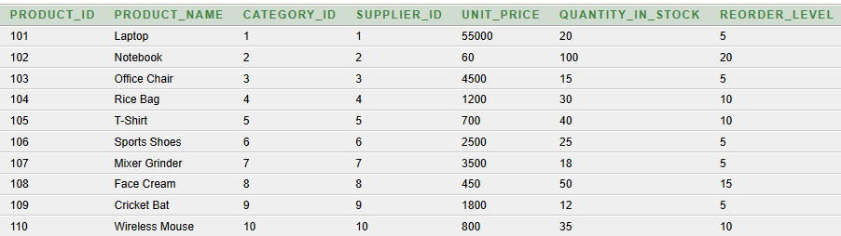
2. Display product names and prices
Question: Display the name and unit price of all products
SELECT Product_Name, Unit_Price FROM Product;
Output:
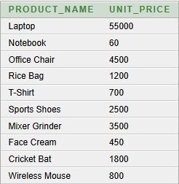
3. Display products with stock greater than 20
Question: Find products whose available stock is greater than 20
SELECT Product_Name, Quantity_in_stock FROM Product WHERE Quantity_in_stock > 20;
Output:
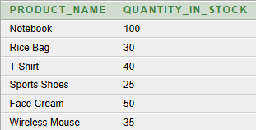
4. Display products with price greater than 1000
Question: Find products whose unit price is greater than ₹1000.
SELECT Product_Name, Unit_Price FROM Product WHERE Unit_Price > 1000;
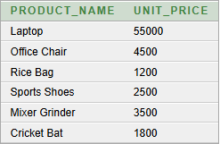
5. Display products in ascending order of price
Question: Display all products from lowest to highest price.
SELECT Product_Name, Unit_Price FROM Product ORDER BY Unit_Price ASC;
Output:
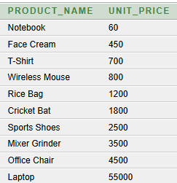

6. Count the total number of products
Question: Find the total number of products in the inventory.
SELECT COUNT(*) AS Total_Products FROM Product;
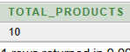
7. Find purchases with total amount greater than ₹10,000
Question: Display purchase details where the total purchase amount is greater than ₹10,000.
SELECT Purchase_ID,Supplier_ID,Purchase_Date,Total_amount FROM Purchase WHERE Total_amount > 10000 ORDER BY Total_amount DESC;

8. Display products with their category names
Question: Display each product along with its category name.
SELECT p.Product_ID, p.Product_Name, c.Category_Name FROM Product p JOIN Category c ON p.Category_ID = c.Category_ID;
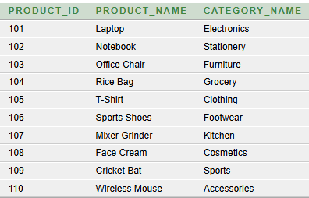
9. Display products with their supplier names
Question: Display each product along with the supplier who supplies it.
SELECT p.Product_Name, s.Supplier_Name FROM Product p JOIN Supplier s ON p.Supplier_ID = s.Supplier_ID;
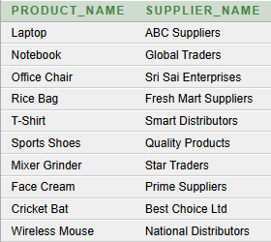
10. Find total purchase quantity for each product
Question: Display each product and the total quantity purchased.
SELECT p.Product_Name, SUM(pd.Quantity) AS Total_Purchased FROM Product p JOIN Purchase_Details pd ON p.Product_ID = pd.Product_ID GROUP BY p.Product_Name;
Output:
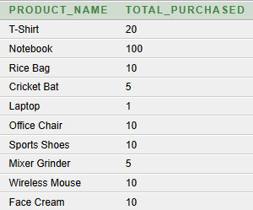
11. Find total sales quantity for each product
Question: Display each product and the total quantity sold.
SELECT p.Product_Name, SUM(sd.Quantity) AS Total_Sold FROM Product p JOIN Sales_Details sd ON p.Product_ID = sd.Product_ID GROUP BY p.Product_Name;
Output:
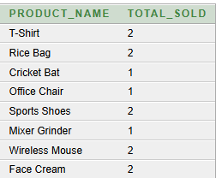
12. Find products priced above the average price
Question: Display products whose unit price is greater than the average product price.
SELECT Product_Name, Unit_Price FROM Product WHERE Unit_Price >(SELECT AVG(Unit_Price)FROM Product);
Output:
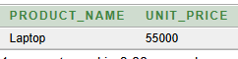
13. Display customer and employee details for each sale
Question: Display the customer name, employee name, sales date, and total amount for each sale.
SELECT c.Customer_Name,e.Employee_Name,s.Sales_Date,s.Total_amount FROM Sales s JOIN Customer c ON s.Customer_ID = c.Customer_ID JOIN Employee e ON s.Employee_ID = e.Employee_ID;
Output:
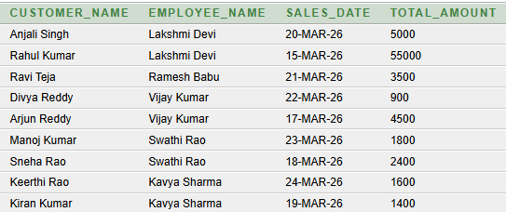
14. Find the product with the highest sales quantity
Question: Display the product that has the highest total sales quantity.
SELECT p.Product_Name,SUM(sd.Quantity) AS Total_Sold FROM Product p JOIN Sales_Details sd ON p.Product_ID = sd.Product_ID GROUP BY p.Product_Name HAVING SUM(sd.Quantity) = (SELECT MAX(Total_Sold) FROM (SELECT SUM(Quantity) AS Total_Sold FROM Sales_Details GROUP BY Product_ID));
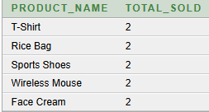

15. Find sales with total amount greater than 2000
Question: Display the sales where the total amount is greater than 2000, sorted from highest to lowest.
SELECT Sales_ID, Customer_ID, Employee_ID, Total_amount FROM Sales WHERE Total_amount > 2000 ORDER BY Total_amount DESC;
Output:
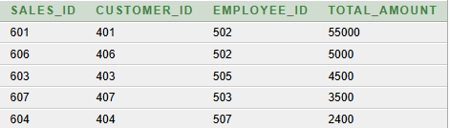

10. CONCLUSION

The Inventory Management System provides a structured relational database solution for managing core inventory operations. The design organizes products, categories, suppliers, purchases, purchase details, customers, sales, sales details, and employees into related relations and applies primary keys, foreign keys, NOT NULL conditions, and suitable constraints to support data integrity.
The normalization process up to 3NF reduces unnecessary redundancy and helps avoid update anomalies. The SQL implementation and query set demonstrate database creation, data insertion, retrieval, joins, aggregation, grouping, subqueries, and inventory reporting. The project therefore provides a suitable DBMS cornerstone implementation that can be extended into a complete inventory management application.

11. FUTURE ENHANCEMENTS
- Barcode/QR Code Integration – Scan products quickly and update stock automatically.
- Low-Stock Alerts – Notify the user when stock reaches the reorder level.
- Online Dashboard – Display sales, purchases, and stock information using charts.
- Automatic Stock Updates – Update inventory automatically after every purchase and sale.
- User Login & Security – Add role-based access for administrators and employees.
- Report Generation – Generate sales, purchase, supplier, and inventory reports.
- Cloud Database – Store and access inventory data securely from different locations.
- Mobile Application – Provide mobile access for checking and managing inventory.

12. REFERENCES

- Korth, H. F., Silberschatz, A., and Sudarshan, S., Database System Concepts, McGraw Hill.
- Elmasri, R. and Navathe, S. B., Fundamentals of Database Systems, Pearson.
- Raghu Ramakirshna and Johannes Gehrke, Database management System 3rd Edition
- Ramez Elmasri and Shamkant B.Navathe, Fundamentals of Database System
- C.J Date,An Introduction to Database System
- Dr.Rajiv Chopra , Database Management Systems

